**SCIENCE PAPER TWO**

*Time: 2:15minutes*

**Pupil’s name :……………………………………………… Index No……………........**

**SECTION MARKS**

**B**

**A**

**DO NOT OPEN THIS BOOKLET UNTIL YOU ARE TOLD TO DO SO**

**Read the following instructions carefully.**

**T**

1. **Read the instructions carefully**

1. **Answer ALL questions in Section A & B**
2. **Answers should be put in the space provided.**
3. **All answers should be written in blue or black ink.**
4. **Unnecessary alterations may lead to loss of marks**
5. **Any handwriting that cannot be read may lead to loss of marks.**
6. Why should school children have a nail cutter as a requirement?

____________________________________________________________________

1. How does weeding control pests in a garden?

____________________________________________________________________

1. Why does digestion of fats begin from the duodenum?

____________________________________________________________________

1. Which exotic breed of cattle is the best milk producer?

____________________________________________________________________

1. Name any one example of a wingless insect.

____________________________________________________________________

1. How can fractures be controlled among school children?

____________________________________________________________________

**The diagram below shows a plant leaf. Use it to answer question 7.**

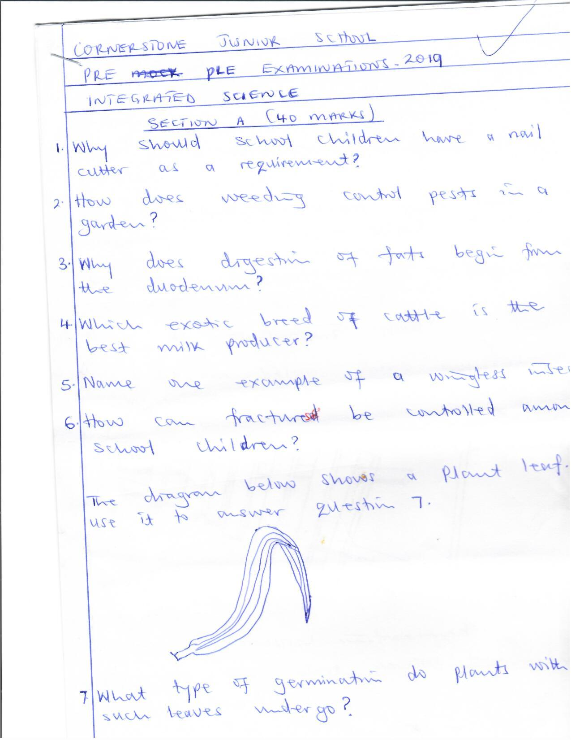

1. What type of germination do plants with such leaves undergo?

____________________________________________________________________

1. How is a proboscis useful to a male mosquito?

____________________________________________________________________

1. Which fungal disease affects the genital areas in humans?

____________________________________________________________________

1. Why are walls of a rabbit hutch made of wire mesh?

____________________________________________________________________

1. Why is mono-cropping a dangerous farming practice?

____________________________________________________________________

1. How do farmers control ants from attacking bees in a hive?

____________________________________________________________________

1. How are animals able to see objects in the environment?

____________________________________________________________________

1. How do mushrooms feed?

____________________________________________________________________

**The diagram below shows a musical instrument. Use it to answer questions 15 and 16.**

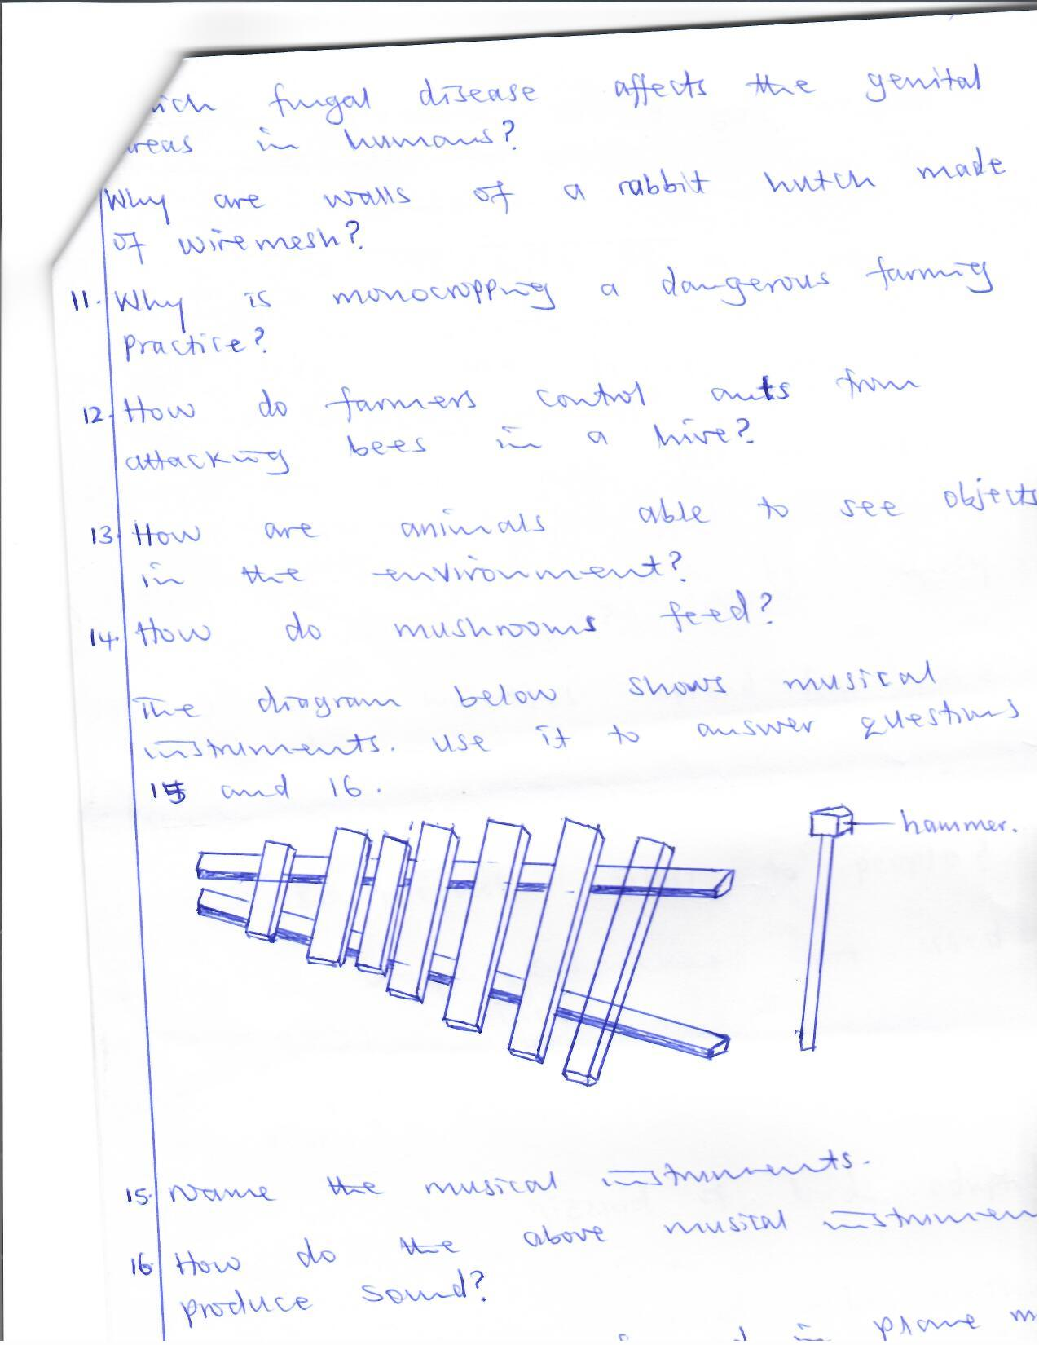

hammer

1. Name the musical instrument.

____________________________________________________________________

1. How does the above musical instrument produce sound?

____________________________________________________________________

1. How are images formed in plane mirrors different from those formed in the eyes?

____________________________________________________________________

1. Why is vasectomy not a good method of family planning to a woman who has not produced children.

____________________________________________________________________

1. Name any one example of a compound fertilizer.

____________________________________________________________________

____________________________________________________________________

1. What does a bee farmer use a swarm catching net for?

____________________________________________________________________

1. Why may some eggs fail to hatch after incubation under good conditions?

____________________________________________________________________

____________________________________________________________________

1. Why is biogas said to be friendly to the environment?

____________________________________________________________________

1. How does measles spread from one person to another?

____________________________________________________________________

1. How is soil useful to plants?

____________________________________________________________________

1. How is alcohol useful to people?

____________________________________________________________________

1. Give one way sugar canes are used as energy resources.

____________________________________________________________________

1. Which part of an onion is eaten by people?

____________________________________________________________________

1. How is the gizzard of birds adapted to its function?

____________________________________________________________________

1. Why are clothes soaked before washing?

____________________________________________________________________

1. Which first aid element absorbs pus and fluids from scalds?

____________________________________________________________________

**The diagram below shows light reflection. Use it to answer questions 31 and 32.**

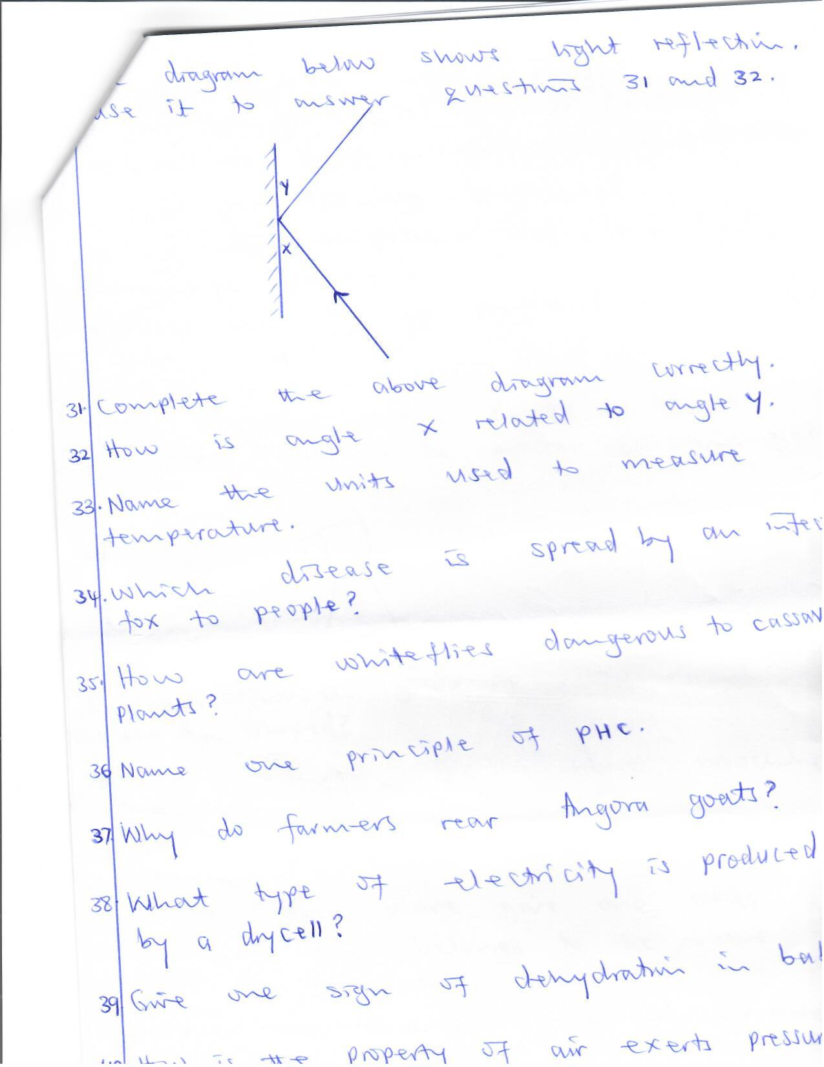

1. Complete the above diagram correctly
2. How is angle x related to angle y?

____________________________________________________________________

1. Name the units used to measure temperature.

____________________________________________________________________

1. Which disease is spread by an infected fox to people?

____________________________________________________________________

1. How are white flies dangerous to cassava?

____________________________________________________________________

1. State any one principle of PHC.

____________________________________________________________________

1. Why do farmers rear Angora goats?

____________________________________________________________________

1. What type of electricity is produced by a dry cell?

____________________________________________________________________

1. Give any one sign of dehydration in babies.

____________________________________________________________________

1. How is the property of air exerts pressure useful to people?

____________________________________________________________________

**SECTION B: 60 MARKS**

1. a) Why do some animals moult?

____________________________________________________________________

b) How is growth similar to rusting?

____________________________________________________________________

c) Give any two ways drought can be prevented.

i)___________________________________________________________________

ii)___________________________________________________________________

1. a) What is teenage pregnancy?

____________________________________________________________________

b) Give any two conditions that can lead to teenage pregnancy.

i)___________________________________________________________________

ii)___________________________________________________________________

c) How can teenage pregnancies be prevented among girls?

____________________________________________________________________

1. 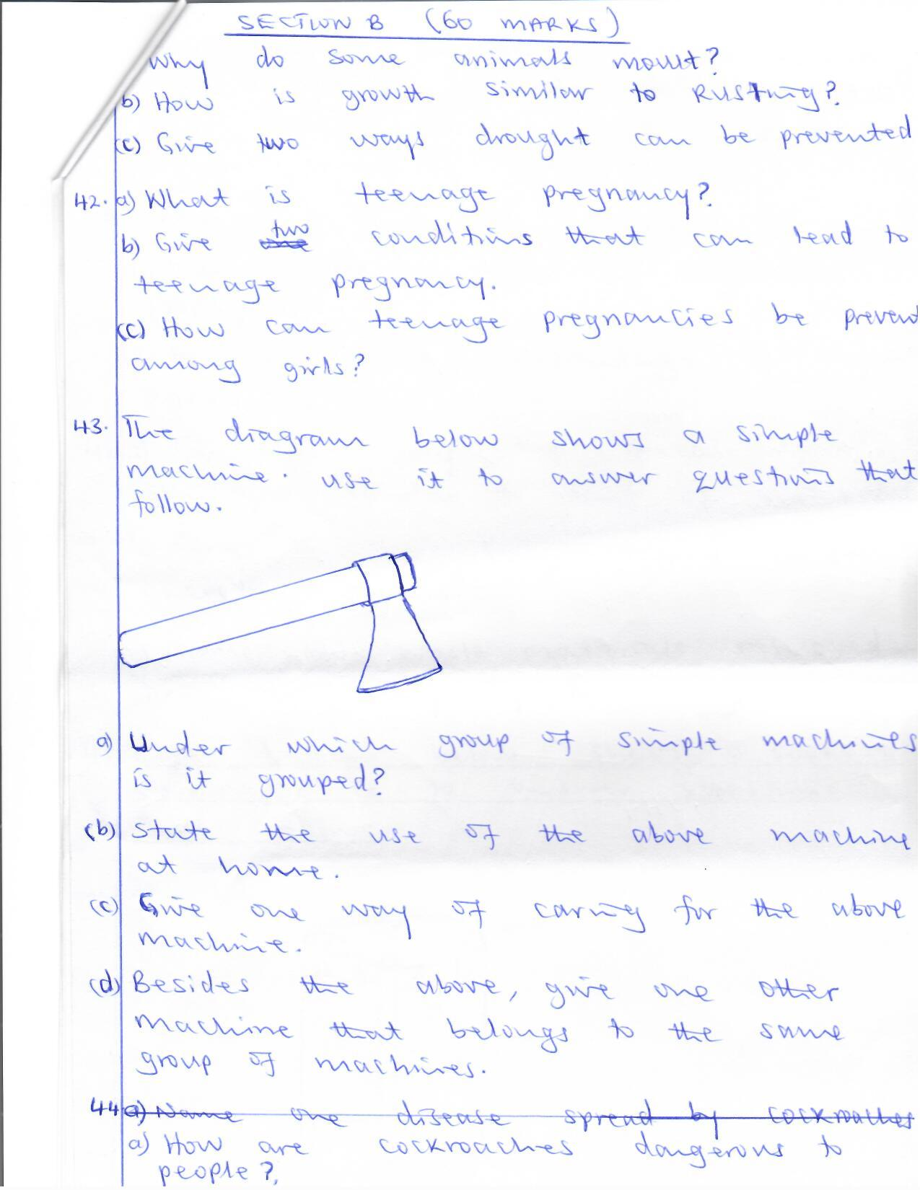**The diagram below shows a simple machine. Use it to answer questions that follow.**
2. Under which group of simple machines is it grouped?

_________________________________________________________________

1. State the use of the above machine at home.

_________________________________________________________________

1. Give any one way of caring for the above machine.

_________________________________________________________________

1. Besides the above, give one other machine that belongs to the same group of machines.

_________________________________________________________________

1. a) How are cockroaches dangerous to people?

____________________________________________________________________

b) How can cockroaches be controlled?

____________________________________________________________________

c) What name is given to the second stage in the life cycle of a cockroach?

____________________________________________________________________

d) How does covering of food prevent diseases spread by cockroaches?

____________________________________________________________________

1. a) What is vegetative propagation?

____________________________________________________________________

b) Name any two methods of vegetative propagation.

i)___________________________________________________________________

ii)___________________________________________________________________

c) Give any one advantage of vegetation propagation.

____________________________________________________________________

1. a) Give one way the function of the skin is similar to that of the kidney.

____________________________________________________________________

b) Why is the liver grouped under excretory organs?

____________________________________________________________________

c) Name two waste materials removed from the body by the lungs.

i)___________________________________________________________________

ii)___________________________________________________________________

1. 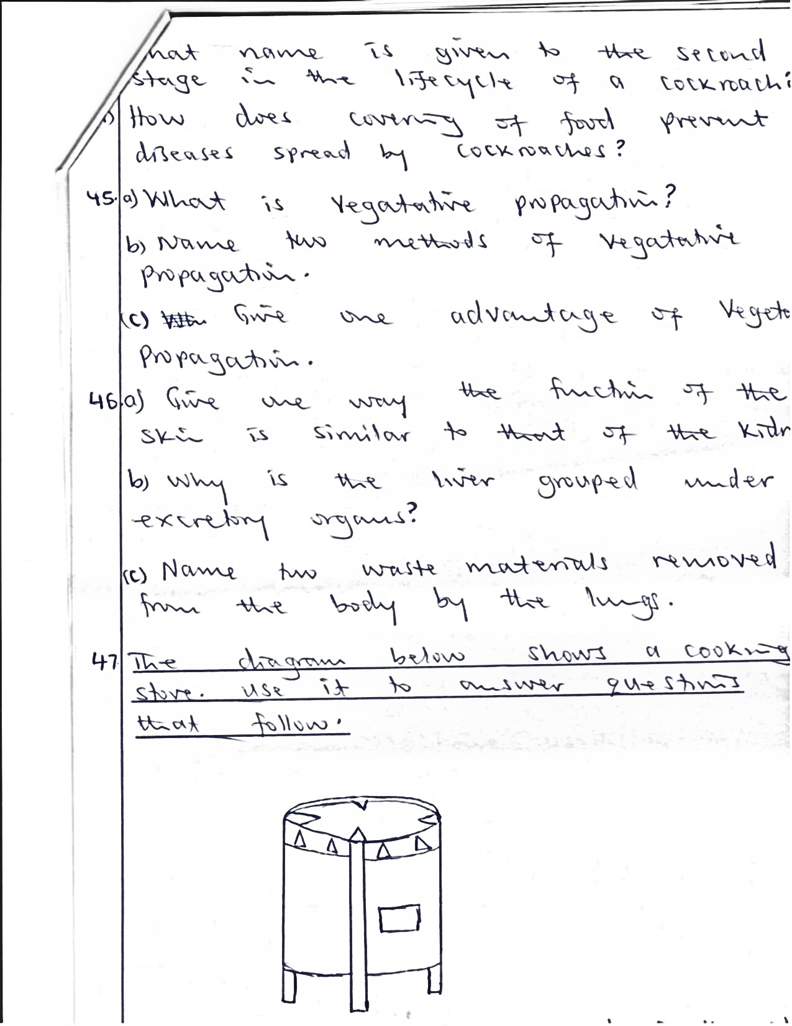**The diagram below shows a cooking stove. Use it to answer questions that follow**
2. What type of fuel is used in the above stove?

_________________________________________________________________

1. How can the above fuel be conserved?

_________________________________________________________________

1. Give any two uses of heat in the environment.

i)________________________________________________________________

ii)________________________________________________________________

1. a) Write PIASCY in full.

____________________________________________________________________

b) Give any one way PIASCY messages are useful to school children.

____________________________________________________________________

c) State any one way HIV / AIDS spreads from one person to another.

____________________________________________________________________

1. How can married couples control the spread of HIV / AIDS?

____________________________________________________________________

1. a) State any one way people hurt animals.

____________________________________________________________________

b) State any two ways animals protect themselves from enemies.

i)___________________________________________________________________

ii)___________________________________________________________________

c) How can people care for wild animals?

____________________________________________________________________

1. a) What is a nursery bed?

____________________________________________________________________

b) State any two importance of growing crops in a nursery bed.

i)___________________________________________________________________

ii)___________________________________________________________________

c) How is pruning different from thinning?

____________________________________________________________________

1. a) What is weight?

____________________________________________________________________

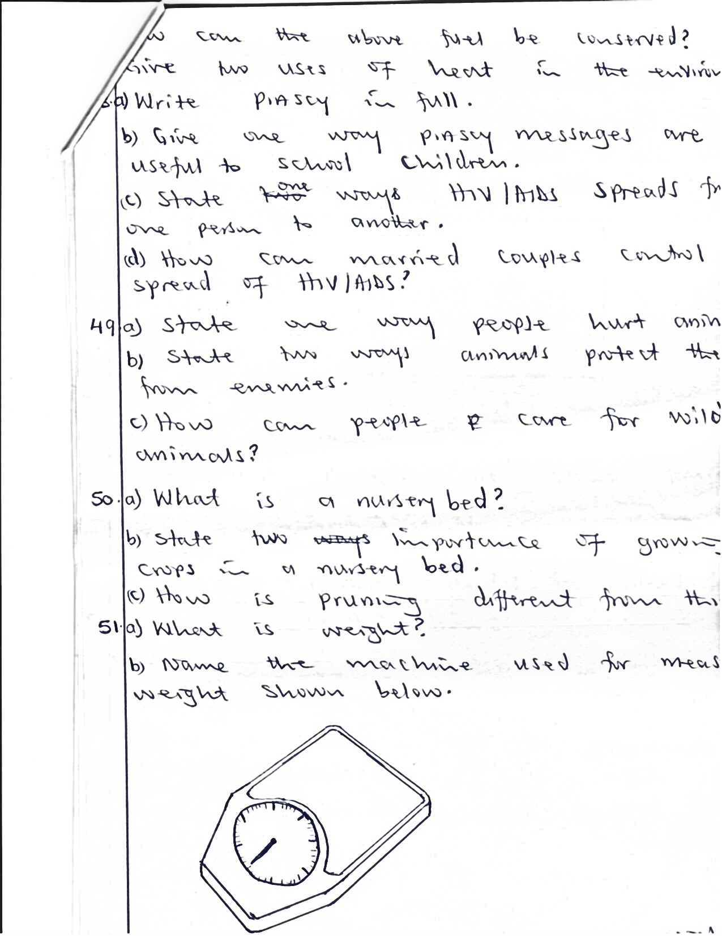b) Name the machine used for measuring weight shown below.

c) What is the standard unit for measuring weight?

_________________________________________________________________

d) Why do objects weigh less when placed in water?

_________________________________________________________________

1. a) Name the eye defect where images in the eye are formed before reaching the retina.

____________________________________________________________________

b) State any two causes of eye defects.

i)___________________________________________________________________

ii)___________________________________________________________________

c) In the space below, draw a lens used to correct long sightedness.

1. a) How are plants useful in the process of rain formation?

____________________________________________________________________

b) By what process are clouds formed?

____________________________________________________________________

c) Which force enables rain from the clouds reach the ground?

____________________________________________________________________

1. How is rainfall useful to plants?

____________________________________________________________________

1. a) Why are moths able to pollinate flowers at night?

____________________________________________________________________

b) State any two characteristics of wind pollinated flowers.

i)___________________________________________________________________

ii)___________________________________________________________________

c) How is maize able to prevent self-pollination?

____________________________________________________________________

1. a) Name any two poultry diseases caused by virus.

i)___________________________________________________________________

ii)___________________________________________________________________

b) State any two ways of controlling diseases in poultry.

i)___________________________________________________________________

ii)___________________________________________________________________

**END**